**How to use MASM in windows 64-bit**

**1)** Run the DOSBox.exe file and install it like any other software.

Now that you’ve installed DOSBox, you’ll be able to run any 16bit or 32bit DOS executable inside it.

**2)** Paste the ‘8086’ folder in c:\

8086 folder contains the files

masm.exe, tasm.exe, link.exe, bin2hex.exe, exe2bin.exe, td.exe, edit.com and debug.exe, ml.exe

**3)** Launch DOSBox and type the following commands :  
  
 mount c c:\8086 c:

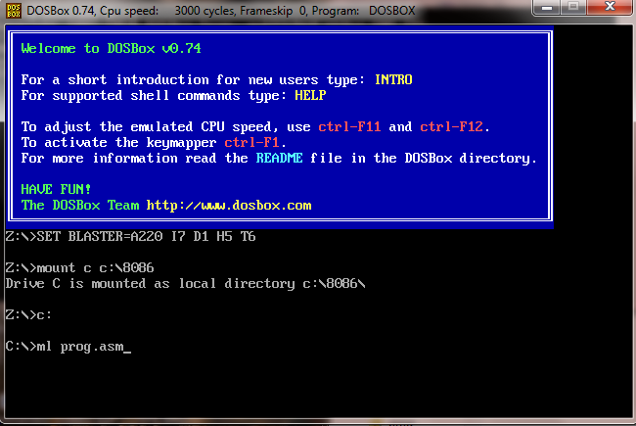

Now you are in c:\8086 directory.

Note: make .asm programs in c:\8080 directory. For example “prog.asm” is already in this directory.

Now use the same commands you use for making, compiling, linking and debugging (edit, ml, masm, link, debug).

**https://www.youtube.com/watch?v=d6MeQSsgqrw**

**Commands**

Masm prog.asm

Link prog.obj

Prog.exe

OR

Ml prog.asm

Prog.exe